BUY BACK OF SHARES AND BONUS SHARES

Introduction: Buy Back of Shares means the purchase by the Company of its own shares. Buy Back of equity shares is an imperative mode of capital restructuring. It is a corporate financial strategy which involves capital restructuring and is prevalent globally with the underlying objectives of increasing Earnings per Share, averting hostile takeovers, improving returns to the stakeholders and realigning the capital structure. Buy Back is an alternative way of Reduction of Capital.
Legal Framework for Buy Back of Shares:
- Companies Act, 2013
- Companies (Share Capital and Debentures) Rules, 2014
- Securities and Exchange Board of India (Buy-back of Securities) Regulations, 1998 and Securities and Exchange Board of India (Buy-back of Securities) (Amendment) Regulations, 2013

Buyback of Shares under Section 68 of Companies Act, 2013
-Section 68 of the Companies Act, 2013 empowers a company to purchase its own shares or other securities in certain cases.
-Sections 68 to 70 of the Companies Act, 2013 and Rule 17 of the Companies (Share Capital and Debentures) Rules, 2014 deal with buy-back of shares.
1. Sources of Buy-Back: A company may purchase its shares out of:
- its free reserves;
- the securities premium account; or
- the proceeds of the issue of any shares or other specified securities.
However, no buy-back of any kind of shares can be made out of the proceeds of an earlier issue of the same kind of shares.
2. Prohibitions on Buy-Back:
No company shall directly or indirectly purchase its own shares:-
- through any subsidiary company including its own subsidiary companies;
- through any investment company or group of investment companies; or
- if a default, is made by the company, in the repayment of deposits accepted either before or after the commencement of this Act, interest payment thereon, redemption of debentures or preference shares or payment of dividend to any shareholder, or repayment of any term loan or interest payable thereon to any financial institution or banking company, however, the buy-back is not prohibited, if the default is remedied and a period of three years has lapsed after such default ceased to subsist.
- if the company has not complied with the provisions of S. 92 (Annual Return), S. 123 (Declaration of Dividend), S. 127 (punishment for failure to distribute dividend) and S. 129 (Financial Statement)
Provisions for Buy-Back of Shares
1. Authorization for Buy-Back: Articles of Association(AOA) of the company should authorize Buy-Back, if no provision in AOA then first alter the AOA.
2. Approval: The Buy-back can be made with the approval of the Board of directors at a board meeting and/or by a special resolution (SR) passed by shareholders in general meeting, depending on the quantum of buy back:
- Approval of Board of Directors- up to10% of the total paid-up equity capital and free reserves of the company.
- Approval of Shareholders- up to25% of the aggregate of paid-up capital and free reserves of the company.
3. Notice of General Meeting: The notice of the meeting at which the special resolution is proposed to be passed shall be accompanied by an explanatory statement in which the particulars required to be mentioned as per section 68(3) [a to e] and Rule 17(1) [a to n] of Companies (Share Capital and Debentures) Rules, 2014 should be disclosed.
4. Methods of Buy-Back: The Buy-back of shares of private & unlisted public companies may be:
- from the existing shareholders on a proportionate basis;
- by purchasing the securities issued to employees of the company pursuant to a scheme of stock option or sweat equity.
5. Letter of Offer (Form SH-8): Before the buy-back of shares, the company shall file with the Registrar of Companies a Letter of Offer in e-form SH-8 and the Letter of Offer shall be dispatched to the shareholders immediately after filing the same with the Registrar of Companies but not later than 20 days from its filing with the Registrar of Companies ensuring the matters as prescribed in the Sub-rule 10 of Rule 17 of The Companies (Share Capital and Debentures) Rules, 2014.
6. Declaration of Solvency (Form SH-9): The company shall file with the Registrar of Companies, along with the letter of offer, a declaration of solvency in e-Form SH-9.
7. Offer Period: The offer for buy back shall remain open for a minimum period of 15 days but not more than 30 days from the date of dispatch of letter of offer. (Period may be less than 15 days, if all the members agree.)
8. Debt-equity Ratio: The ratio of the aggregate of secured and unsecured debts owed by the company after buy-back shall not be more than twice the paid-up capital and its free reserves.
9. Fully Paid-up Shares: Shares to be bought back must be fully paid up.
10. Time limits: Buy-back shall be completed within a period of 1 (one) year from the date of passing of SR or Board Resolution, as the case may be. No offer of buy-back shall be made within a period of one year from the date of the closure of the preceding offer of buy-back, if any.
11. Acceptance of Offer: In case the number of shares offered by the shareholders is more than the total number of shares to be bought back by the company, the acceptance per shareholder shall be on proportionate basis out of the total shares offered for being bought back.
12. Verification: The company shall complete the verifications of the offers received within fifteen days from the date of closure of the offer and the shares lodged shall be deemed to be accepted unless a communication of rejection is made within twenty-one days from the date of closure of the offer.
13. Separate Bank Account: After the closure of the buy-back offer, the company shall immediately open a separate bank account and deposit therein, such sum, as would make up the entire sum due and payable as consideration for the shares tendered for buy-back.
14. Payment: Within 7 days from the date of verification of the offers:
- Make payment of consideration in cash to those shareholders whose shares have been accepted.
- Return the share certificates to those shareholders whose shares are not accepted at all or the balance of shares, if partly accepted.
15. Extinguishment of Shares: The company shall Extinguish and physically destroy the shares bought back within 7 days of the last date of completion of buy back.
16. Prohibition on further issue of shares: The company shall not make a further issue of the same kind of shares including allotment of new shares under Clause (a) of Sub-section (1) of Section 62 within a period of six months except by way of a bonus issue or in the discharge of subsisting obligations such as conversion of warrants, stock option schemes, sweat equity or conversion of preference shares or debentures into equity shares.
17. Register of Buy-Back (Form SH-10): The Company shall maintain a register of shares which has been bought back in Form SH-10.
18. Return of Buy-Back (Form SH-11):The Return of Buy back with the Registrar in Form SH-11 on completion of buy back along with the certificate in Form SH-15 certifying that the buy-back of shares has been made in compliance with the provisions of the Act and rules within 30 days of such completion.
19. Capital Redemption Reserve Account: If the buy-back of shares is made out of free reserves or securities premium account a sum equal to the nominal value of the shares so purchased shall be transferred to the capital redemption reserve account and details of such transfer shall be disclosed in the balance sheet and the amount of the said reserve may be applied by the company, in paying up unissued shares of the company to be issued to members of the company as fully paid bonus shares.
20. Punishment: If a company makes any default in complying with the provisions of Section 68, then the punishment shall be as follows:
Company Fine not less than Rupees One Lakh but which may extend to Rupees Three Lakh.
Every officer Imprisonment for a term which may extend to three years or with fine which shall not be less than Rupees One Lakh, but which may extend to Rupees Three Lakh, or with both.

Buyback of Shares Procedure

- FILING OF LETTER OF OFFER WITH THE REGISTRAR (RULE 17(2)):
The company which has been authorized by a special resolution shall, before the buy-back of shares, file with the Registrar of Companies a letter of offer in Form No SH 8,Such letter of offer shall be dated and signed on behalf of the Board of directors of the company by not less than two directors of the company, one of whom shall be the managing director.

-DISPATCH OF LETTER OF OFFER TO SHAREHOLDERS(RULE 17(4)):
The letter of offer shall be dispatched to the shareholders immediately after filing the same with the Registrar of Companies but not later than 21 days from its filing with the Registrar of Companies.

-OFFER PERIOD RULE 17 (5):
As per Rule 17 (5) The offer for buy-back shall remain open for a period of not less than fifteen days and not exceeding thirty days from the date of dispatch of the letter of offer. Provided that where all members of a company agree, the offer for buy-back may remain open for a period less than fifteen days.

-REGISTER OF BUYBACK OF SHARES :
The company, shall maintain a register of shares or other securities which have been bought-back in FORM NO. SH.10.[rule 17(12)]

-CERTIFICATION OF COMPLIANCE:
There shall be annexed to the return filed with the Registrar in Form No. SH.11, a certificate in Form No. SH.15signed by two directors of the company including the managing director, if any, certifying that the buy-back of securities has been made incompliance with the provisions of the Act and the rules made thereunder. [rule 17(14)]
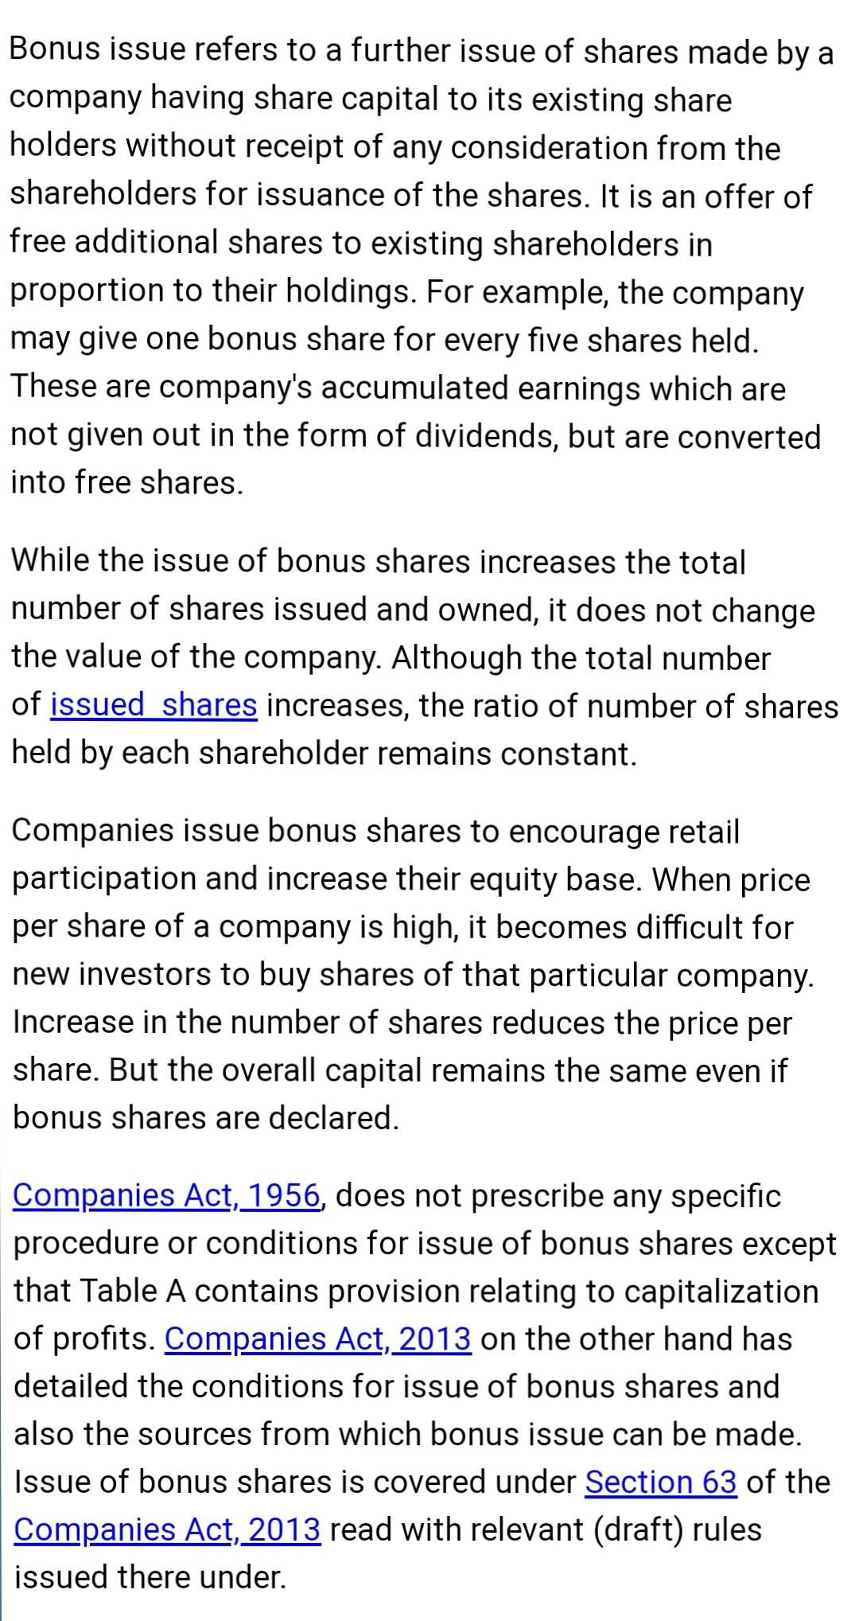
BONUS SHARES

