Com-GE-1016: Micro Economics
Unit:-2 Production and Cost
Class:-1st
Semester:- I Date:-03/09/2022
Time: - 10:00 am

Meaning
An isoquant is a firm’s counterpart of the consumer’s indifference curve. An isoquant is a curve that shows all the combinations of inputs that yield the same level of output. ‘Iso’ means equal and ‘quant’ means quantity. Therefore, an isoquant represents a constant quantity of output. The isoquant curve is also known as an “Equal Product Curve” or “Production Indifference Curve” or Iso-Product Curve.”
The concept of isoquants can be easily explained with the help of the table given below:

Table 1: An Isoquant Schedule
Combinations of Labor and Capital | Units of Labor (L) | Units of Capital (K) | Output of Cloth (meters)
A | 5 | 9 | 100
B | 10 | 6 | 100
C | 15 | 4 | 100
D | 20 | 3 | 100

The above table is based on the assumption that only two factors of production, namely, Labor and Capital are used for producing 100 meters of cloth.
Combination A = 5L + 9K = 100 meters of cloth
Combination B = 10L + 6K = 100 meters of cloth
Combination C = 15L + 4K = 100 meters of cloth
Combination D = 20L + 3K = 100 meters of cloth
The combinations A, B, C and D show the possibility of producing 100 meters of cloth by applying various combinations of labor and capital. Thus, an isoquant schedule is a schedule of different combinations of factors of production yielding the same quantity of output.
An iso-product curve is the graphic representation of an iso-product schedule.
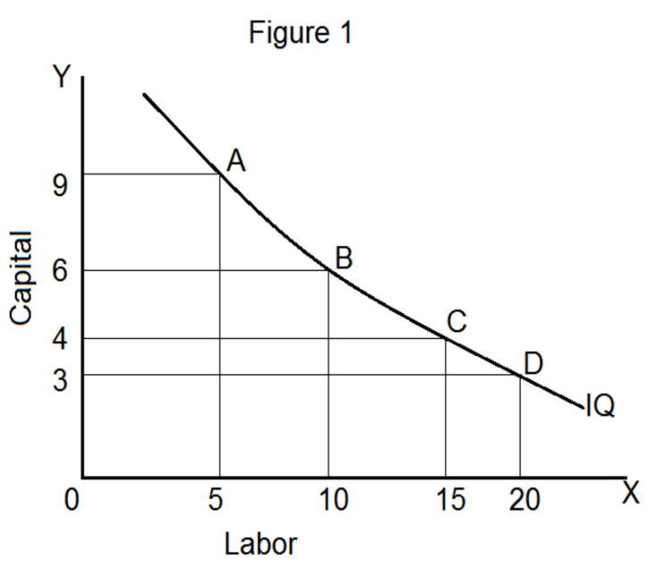
Thus, an isoquant is a curve showing all combinations of labor and capital that can be used to produce a given quantity of output.
Isoquant Map
An isoquant map is a set of isoquants that shows the maximum attainable output from any given combination inputs.
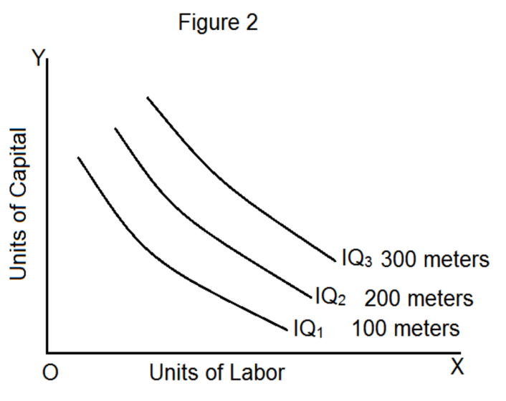

Properties of Isoquants
1. An isoquant lying above and to the right of another isoquant represents a higher level of output.This is because of the fact that on the higher isoquant, we have either more units of one factor of production or more units of both the factors. TAt point A we have = OX₁ units of Labor and OY₁ units of capital.
At point B we have = OX₂ units of Labor and OY₁ units of capital.
Though the amount of capital (OY₁) is the same at both the points, point B is having X₁X₂ units of labor more. Therefore, it will yield a higher output.
Hence, it is proved that a higher isoquant shows a higher level of output. This has been illustrated in figure 3. In figure 3, points A and B lie on the isoquant IQ₁ and IQ₂ respectively.
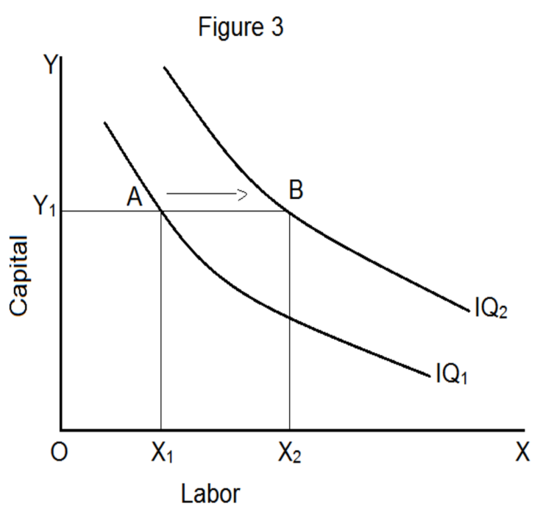
2. Two isoquants cannot cut each other
Just as two indifference curves cannot cut each other, two isoquants also cannot cur each other. If they intersect each other, there would be a contradiction and we will get inconsistent results. This can be illustrated with the help of a diagram as in figure 4.
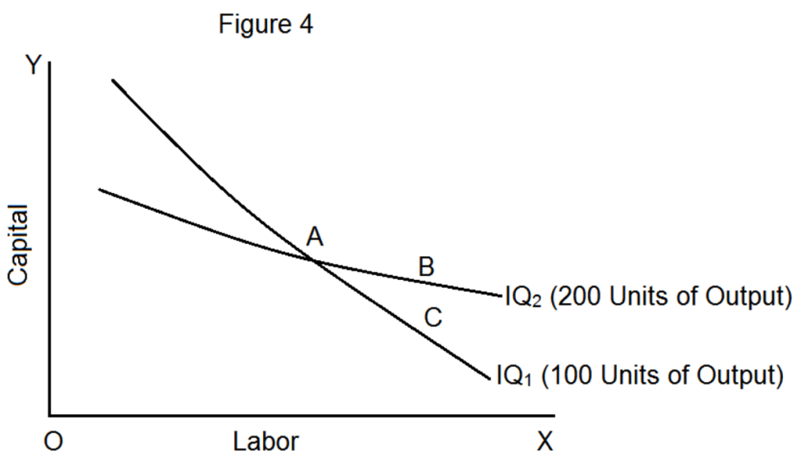
In figure 4, the isoquant IQ₁ shows 100 units of output produced by various combinations of labor and capital and the curve IQ₂ shows 200 units of output,
On IQ₁, we have A = C, because they are on the same isoquant.
On IQ₂, we have A = B
Therefore B = C
This is however inconsistent since C = 100 and B = 200. Therefore, isoquants cannot intersect.
3. Isoquants are convex to the origin
An isoquant must always be convex to the origin. This is because of the operation of the principle of diminishing marginal rate of technical substitution. MRTS is the rate at which marginal unit of an input can be substituted for another input making the level of output remain the same.
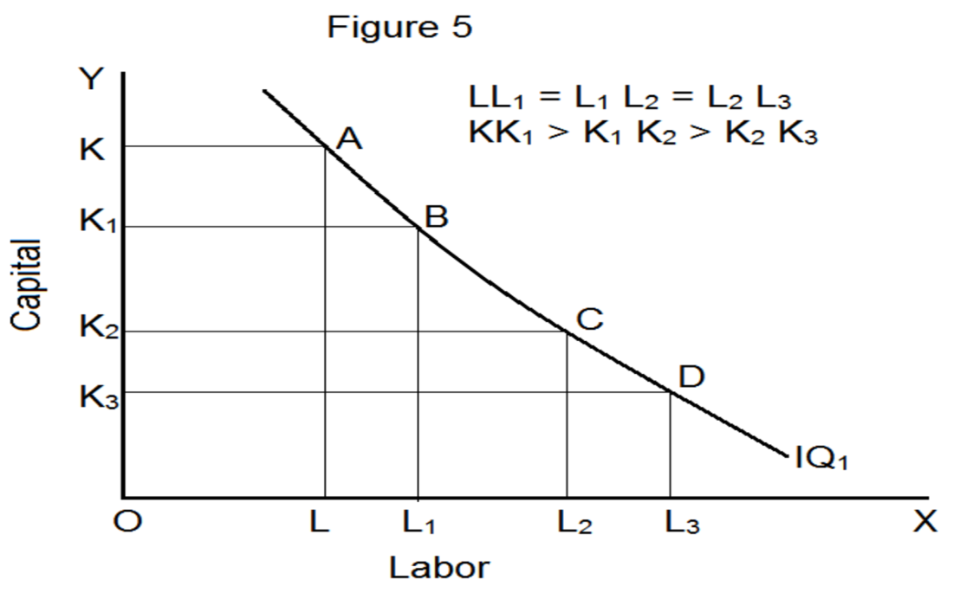
In figure 5, as the producer moves from point A to B, from B to C and C to D along an isoquant, the marginal rate of technical substitution (MRTS) of labor for capital diminishes. The MRTS diminishes because the two factors are not perfect substitutes. In figure 5, for every increase in labor units by (ΔL) there is a corresponding decrease in the units of capital (ΔK) It cannot be concave as shown in figure 6. If they are concave, MRTS of labor for capital increases. But this is not true of isoquants.
Since MRTS must diminish, the isoquants must be convex to the origin.
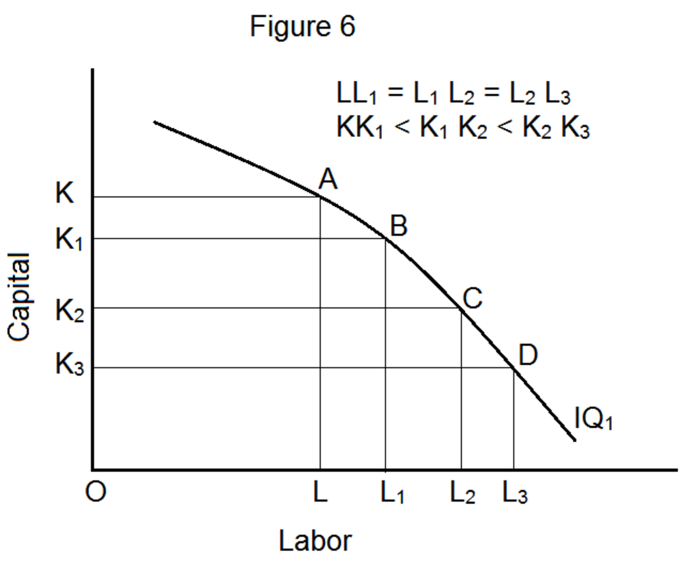
4. No isoquant can touch either axis
If an isoquant touches the X-axis it would mean that the commodity can be produced with OL units of labor and without any unit of capital.
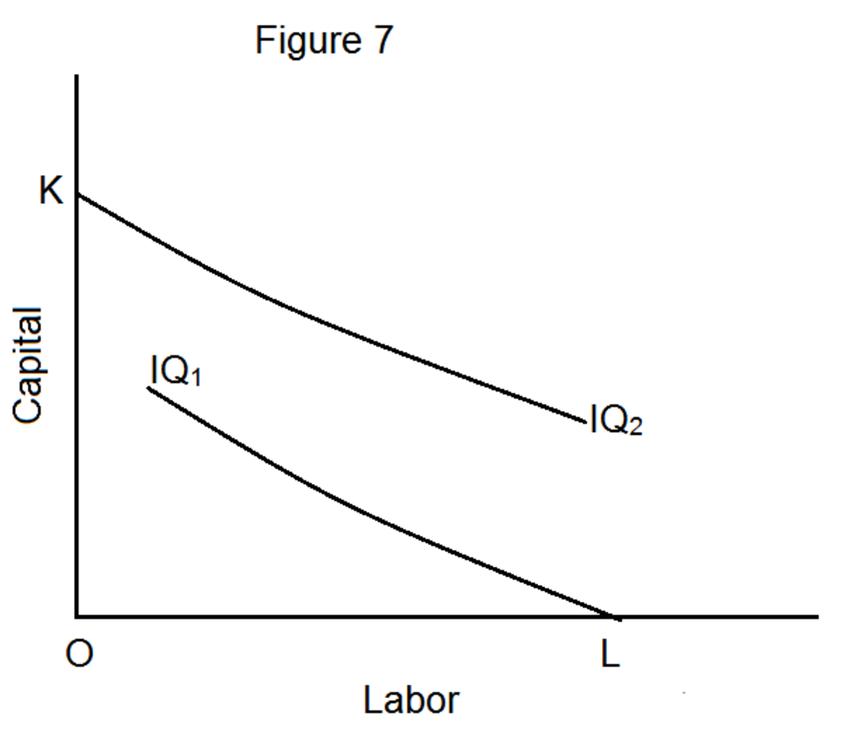
Point K on the Y-axis implies that the commodity can be produced with OK units of capital and without any unit of labor. However, this is wrong because the firm cannot produce a commodity with one factor alone.
5. Isoquants are negatively sloped
An isoquant slopes downwards from left to right. The logic behind this is the principle of diminishing marginal rate of technical substitution. In order to maintain a given output, a reduction in the use of one input must be offset by an increase in the use of another input.
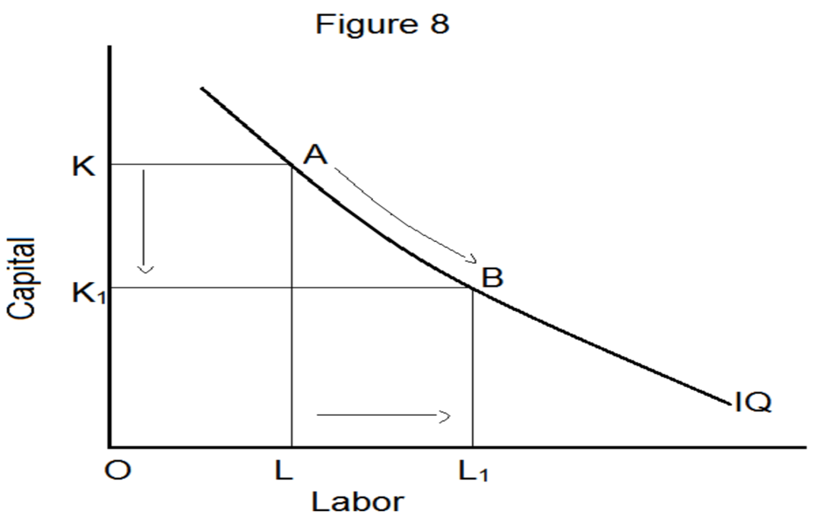
Figure 8 shows that when the producer moves from point A to B, the amount of labor increases from OL to OL₁, but the units of capital decreaseThe impossibility of horizontal, vertical or upward sloping isoquants can be shown with the help of the following diagrams.
Consider figure 9(A)
At point A, we have OL units of labor and OK units of capital and at B, we have OL₁ units of labor and OK units of capital.
OL₁ + OK > OL + OK, and so combination B will yield a higher output than A. Therefore, points A and B on the IQ curve cannot represent an equal level of the product. Hence,s from OK to OK₁, to maintain the same level of output. the isoquant cannot be a horizontal straight line like AConsider figure 9(B)
At point A, we have OL units of labor and OK units of capital. At point B, we have OL units of labor and OK₁ units of capitaB.

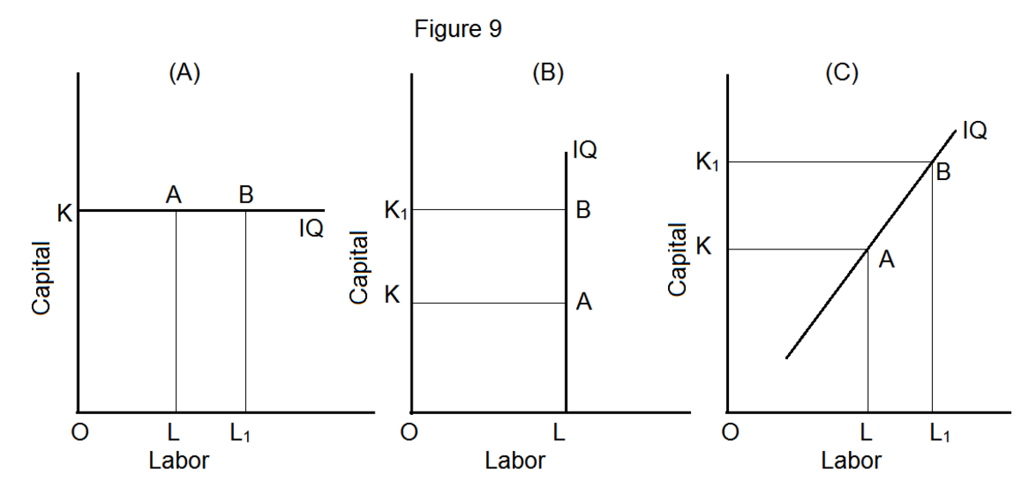
Since B is having KK₁ more units of capital it is wrong to assume that both A and B will yield the same level of output. The conclusion is that the isoquant cannot be a vertical straight line.
Similarly at point B in figure 9(C), we have LL₁ units of more labor and KK₁ units of more capital. As compared to point A, both the inputs are higher at point B. Therefore, it is absurd to assume that both the combinations A and B will give the same level of output.
6. Isoquants need not be parallel
The shape of an isoquant depends upon the marginal rate of technical substitution. Since the rate of substitution between two factors need not necessarily be the same in all the isoquant schedules, they need not be parallel.
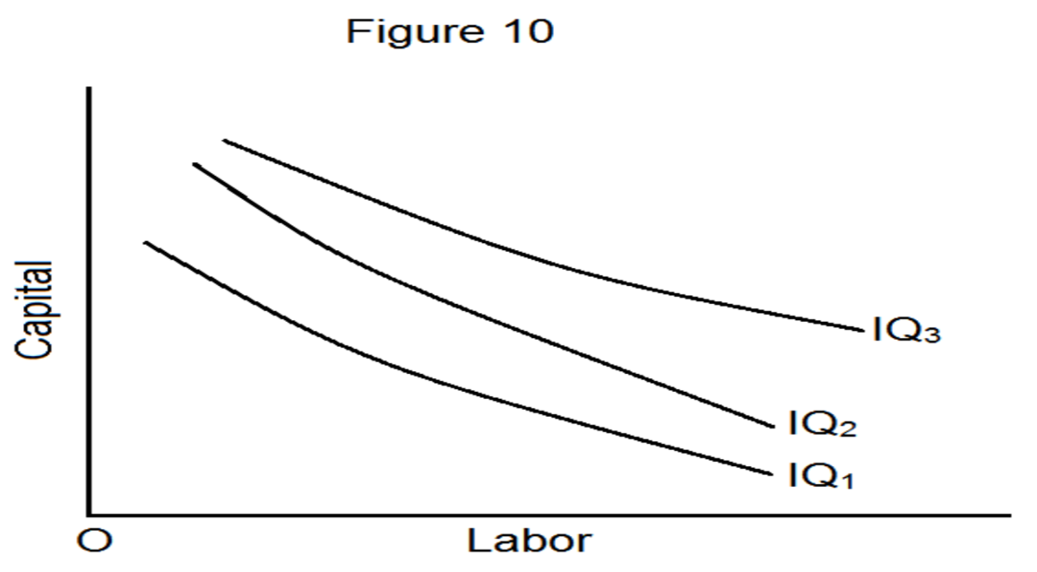
7. Each isoquant is oval-shaped
An important feature of an isoquant is that it enables the firm to identify the efficient range of production consider figure 11.
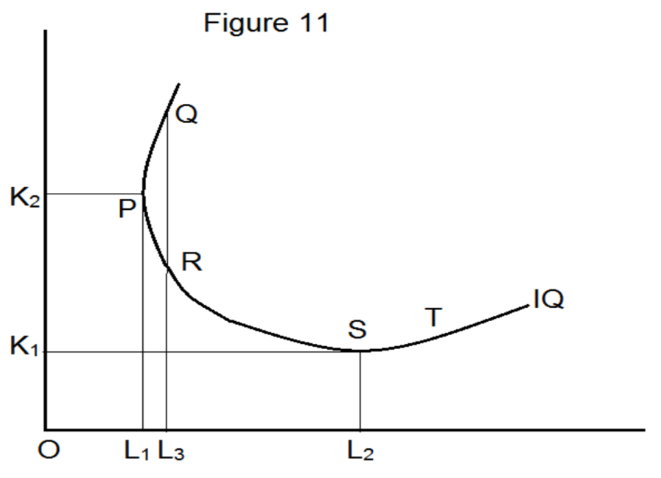
Both the combinations Q and P produce the same level of total output. But the combination Q represents more of capital and labor than P. combinations Q must therefore be expensive and would not be chosen. The same argument can be made to rule out combination T or any other combination lying on a portion of the isoquant where the slope is positive. Positively sloped isoquants imply that an increase in the use of labor would require an increase in the use of capital to keep production constant.
In general, for any input combination on the positively sloped portion of an isoquant, it is possible to find another input combination with less of both the inputs on the negatively convex portion that will produce the same level of output. Therefore, only the negatively sloped segment of isoquant is economically feasible.
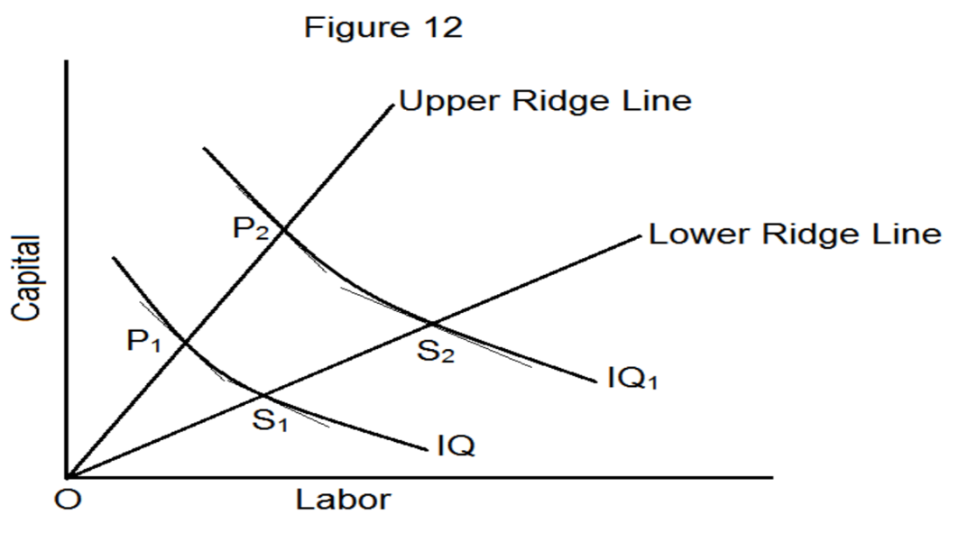
In figure 12, the segment P₁S₁ is the economically feasible portion of the isoquant for IQ. If we consider such feasible portions for all the isoquants, then the region comprising of these portions is called the economic region of production. A producer will operate in this region. It is shown in figure 12. The lines OP₁P₂ and OS₁S₂ are called ridge lines. Ridge lines may be defined as lines separating the downward sloping portions of a series of isoquants from the upward sloping portions. They give the boundary of the economic region of production.

